# Maximum products sold in which country

select count(*)as max_sales,geolocation_city from olist_geolocation_dataset

group by geolocation_city

order by 1 desc

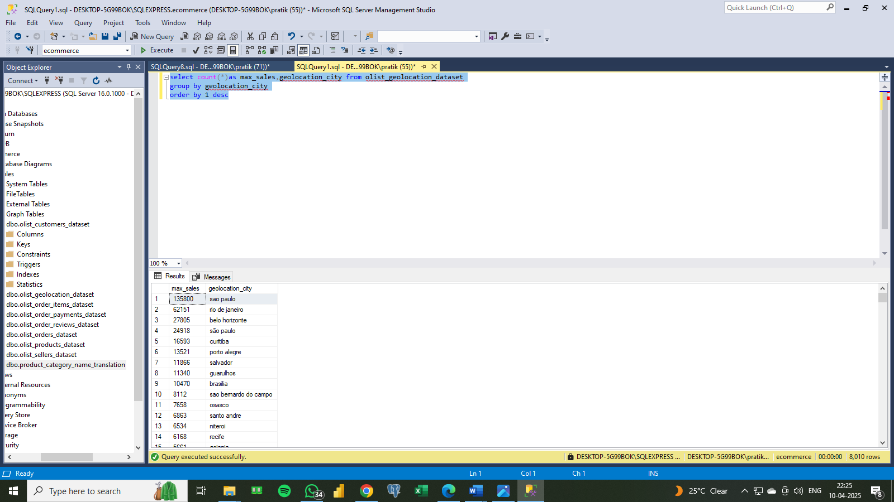

# Count how many perfume were sold

select count(o.order_id) as number_of_perfumes from products_dataset p

inner join order_items_dataset o on p.product_id = o.product_id

where p.product_category_name = 'perfumaria'

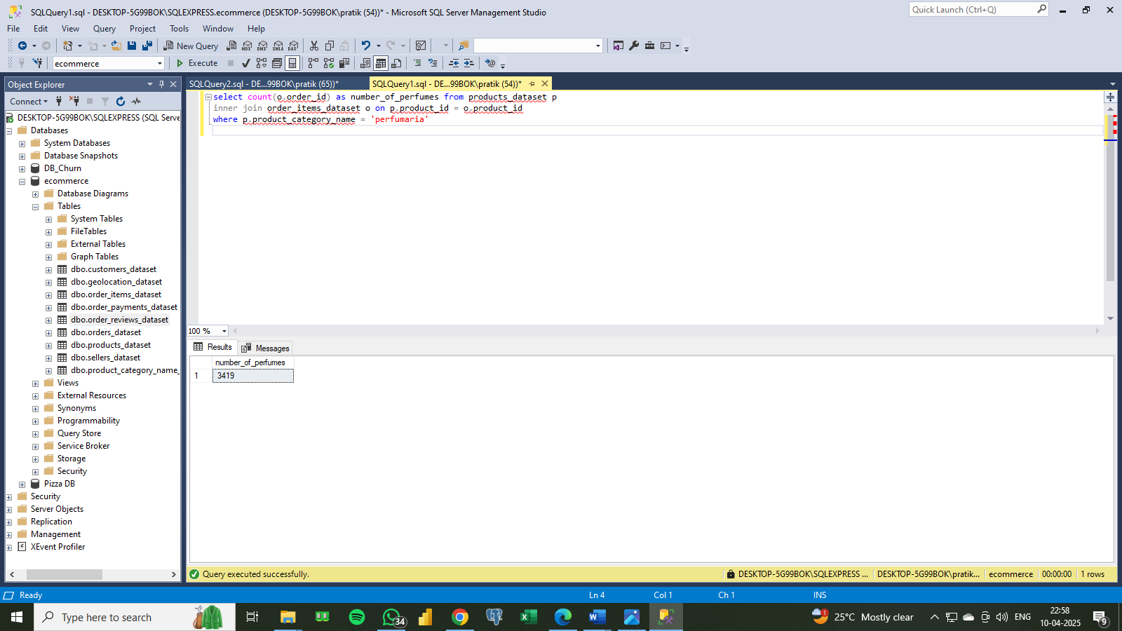

# Find the price of the most expensive item

select max(price)as most_expensive_item from

order_items_dataset

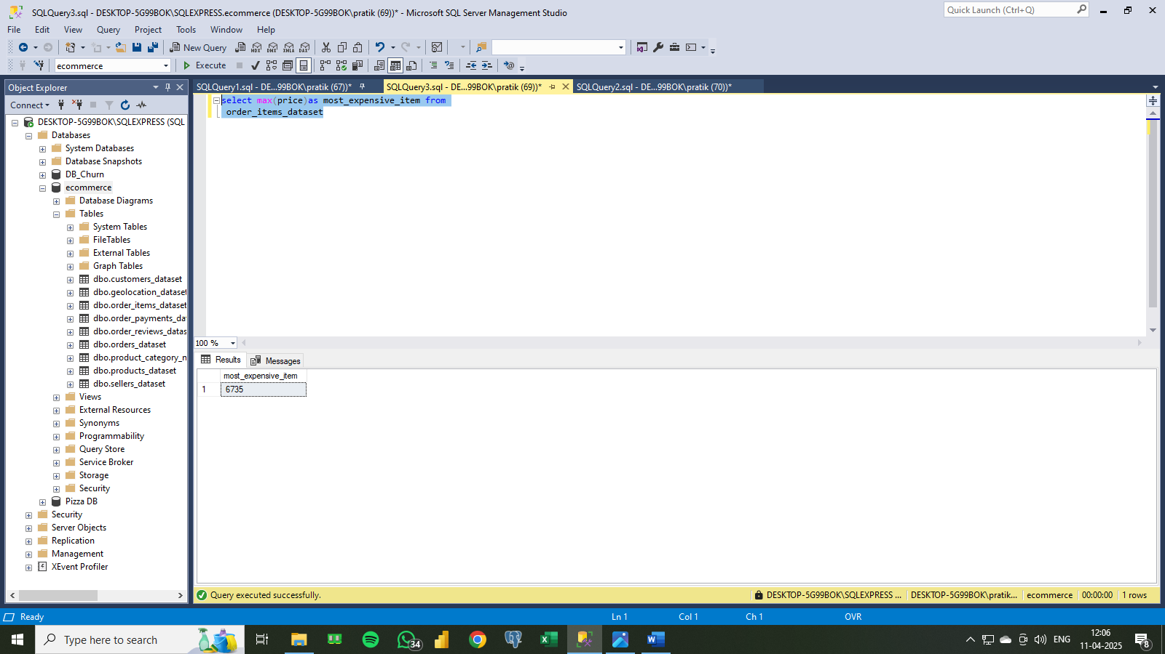

# 4.Find the average payment value

select avg(payment_value)as avg_payment_value

from order_payments_dataset

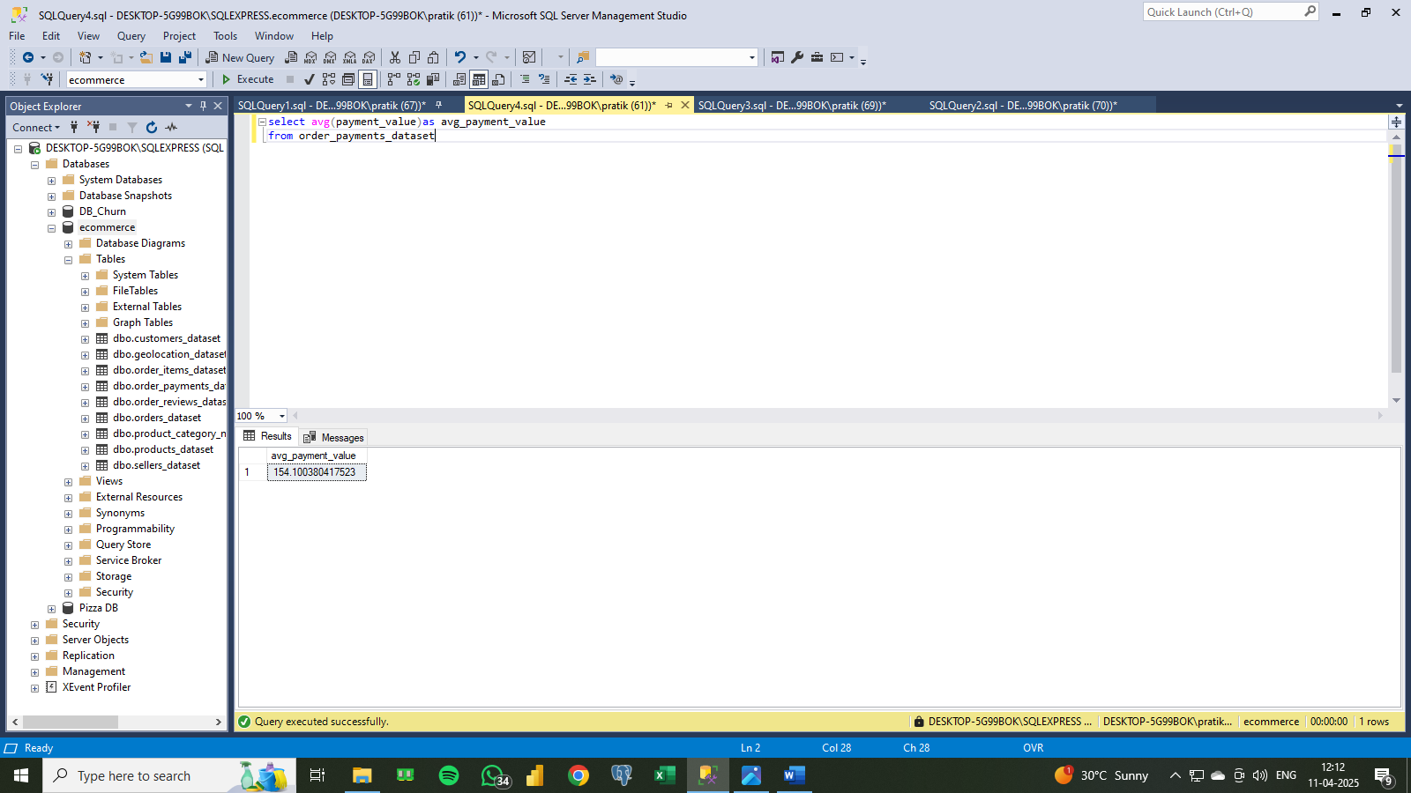

# Find the product category of the most expensive item

select p.product_category_name,o.price from products_dataset p right

join order_items_dataset o on

p.product_id = o.product_id

where o.price in (select

max(price) from order_items_dataset)

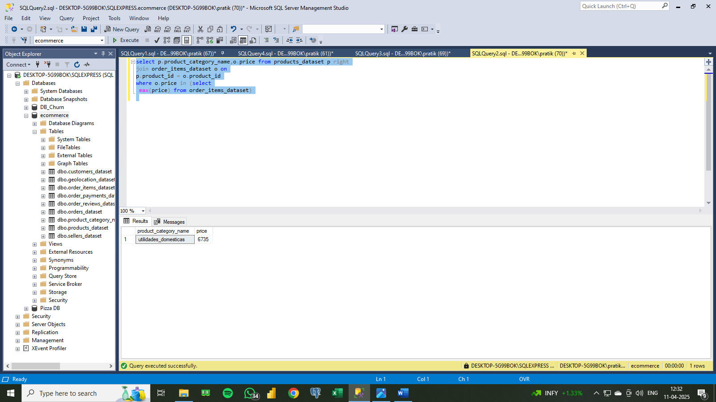

# Created a view for price greater than the average price for further analysis

create view vw_price_greater_than_avg as

select p.product_category_name,o.price from products_dataset p right

join order_items_dataset o on

p.product_id = o.product_id

where o.price > (select

avg(price) from order_items_dataset)

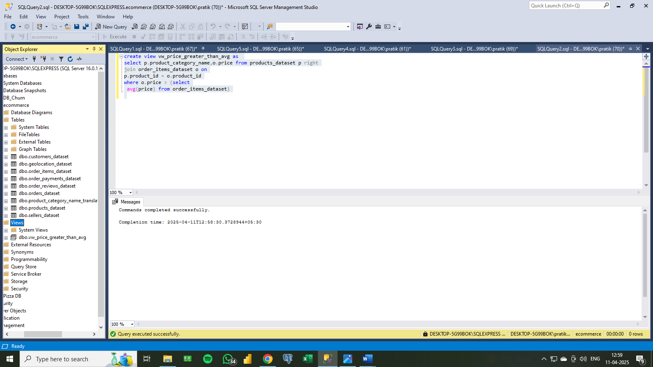

# Created a index on price (*to optimize performance)

create index idx_price

on order_items_dataset (price);

